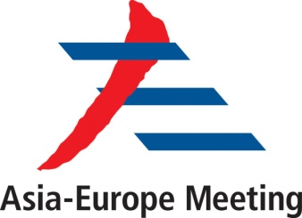

ASEM FMM13
20-21 November 2017, Nay Pyi Taw

PROVISIONAL AGENDA
‘Strengthening Partnership for Peace and Sustainable Development’

1. Opening Remarks
2. Adoption of Agenda
3. Business Arrangements
4. Plenary I – ‘Synergizing Peace and Sustainable Development’
a. Focusing cooperation on areas of common interest
(such as WMD non-proliferation, countering terrorism and violent extremism, cyber security)
b. Reinforcing partnership
(such as UN’s Sustainable Development Goals, climate change, disaster risk reduction and management, food, water and energy security, poverty eradication)
5. Plenary II – ‘3rd Decade of ASEM: Making ASEM Partnership more Dynamic and Connected’
(ASEM’s value & partnership, connectivity across diverse domains, people-to-people contacts, transport, tourism, culture, education, trade and investment cooperation)
6. Retreat Session : International and Regional Issues
(Suggested topics: promotion of peace, traditional and non-traditional security challenges in Asia and Europe)
7. Other Matters
8. Closing Remarks
******

