As of 24 August 2017
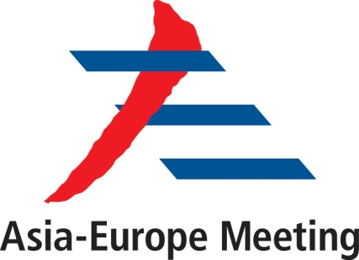

ASEM Symposium
On Countering Radicalisation

The St. Regis,
Kuala Lumpur, 25-26 October 2017

Concept Paper

- Background

Radicalisation is a complex process that is influenced by a combination of factors namely, norms and values, push-and-pull factors, as well as socio-political and socio-economic circumstances. Hence, in order for governments to develop effective policies and programmes to counter radicalisation, such complexities have to be understood in a comprehensive manner.

Questions as to what constitutes radicalisation, along with why and how it happens, who are susceptible, which are the vulnerable groups and how we formulate effective and sustainable responses, must be addressed by States with a view to maintaining national, regional and international security.

The growing number of Foreign Terrorist Fighters (FTF) continues to be a major consequence of radicalisation. It is estimated that over 40,000 FTF from approximately 100 countries, including those in Southeast Asia, have participated in terrorist acts by Daesh and other terrorist groups. While some FTF remain in the Daesh-controlled areas, many have been directed to return to their home countries or move to third countries to continue to pursue the group’s agenda. These include recruiting new followers, promoting its propaganda through the social media and joining local affiliates in carrying out terrorist attacks against the government. These developments pose a grave security threat to many countries.

In accordance with multiple United Nations Security Council Resolutions, and pursuant to the various pronouncements by ASEM relating to countering radicalisation, extremism and terrorism, the international community should continue to intensify its collective efforts in a more cohesive and coherent manner. There is an increasing need for countries to enhance international and regional cooperation. This could be achieved through the sharing of experiences, expertise and best practices among policy makers, law enforcement officers and counter terrorism experts.

- Objective

The Symposium on Countering Radicalisation aims to achieve the following objectives:

- Provide ASEM Member Partners a platform to share knowledge, experience and expertise on countering radicalisation,

- Assist ASEM Member Partners in enhancing understanding on multi-dimensional issues that could lead to or trigger radicalisation,

- Create an informal ASEM network of experts on countering radicalisation and related issues,

- Increase awareness and highlight the importance of soft approaches in countering radicalisation; and

- Explore closer cooperation within the ASEM framework in the areas of de-radicalisation, preventing extremism and countering terrorism.

- Proposal for the Symposium

Radicalisation is a cause of concern for all. Hence it is imperative that we:

- Understand the current state of affairs;
- Identify gaps at the policy and implementation levels;
- Review lessons learned; and
- Suggest recommendations at the strategic and operational levels.

- Format of the Symposium

The Government of Malaysia proposes to organise a one-and-a-half day symposium for both policy-makers and practitioners in the field of counter-terrorism. The subjects that would be covered in this symposium include:

- Moderation and Countering Extremism.
- Strategic Communication and Online Radicalisation.
- Dealing with Foreign Terrorist Fighters (FTF).
- The Science of Rehabilitation and the Art of Reintegration In Countering Radicalisation.
- Community Engagement.
- Countering the Narrative.

- Co-Sponsorship

ASEM Member Partners who are interested to co-sponsor this symposium are welcome to comment on the concept and programme. Co-sponsors are also welcome to provide speakers on the suggested topics in Section D.

- Other Relevant Information

- Participants of the symposium will comprise policy makers, law enforcement officers and counter terrorism experts engaged in the fight against terrorism from ASEM Member Partners. The symposium is not open to the general public or the media.
- The format of the symposium will be lecture-based with panel discussions.
- The language of the lectures and discussions will be English.
- Participants are expected to bear travelling and accommodation expenses.
- The Southeast Asia Regional Centre for Counter-Terrorism (SEARCCT), Ministry of Foreign Affairs, Malaysia, in collaboration with the ASEM Contact Point for Malaysia will jointly organise the symposium.

